Dart Board Setup

Face of board to the Toe Line (The Hockey) 7'9½" or 93½" = (2375 mm)
Center of Bull to floor = 5'8" or 68" = (1727mm)
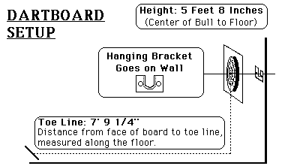
Plus if you measure from the center of the bull to the Toe Line it should be 9' 7 3/8"

